Chapter 2

The Landscape before Enclosure

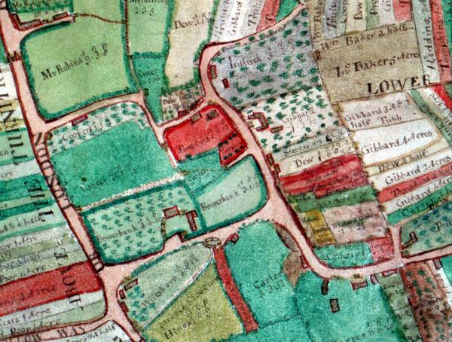
From time out of mind the land in the Wantage area, along with much of the rest of Berkshire, had been worked communally with large common arable fields and livestock grazing on the waste. Visually the landscape would have looked surprisingly modern. The historian W.G. Hoskins, one of the foremost twentieth-century writers on the history of the landscape, noted, ‘The open-field landscape must have been one of great beauty, with its long sweeping lines disappearing miles away over the low… horizons.’ Hoskins was writing in 1957 before the grubbing up of thousands of miles of hedgerow came to be considered an ecological issue. The more modern eye now mourns the lost pattern of small, hedged fields so typical of many parliamentary enclosures. It is this countryside, rather than the open-field landscape admired by Hoskins, that has come to be seen as traditional and quintessentially English. Enclosure was once as controversial as modern prairie farming is today. On one side were the advocates of modern methods and efficiency. On the other were the traditionalists who could see little value in what were then modern methods.
Fig. 2.1 Charlton Village In a common field village the homesteads and closes, were typically located along the main road through the village. In addition to the ‘backfields’ were other small closes. Like the backfield these could be used for livestock or for crops. They were also often orchards. The village pound, seen along the road on the map, was an essential feature of common field husbandry.
Source: BRO D/ECo P1

The Common Field Village

The common field village was different from one farmed in severalty both in the way it functioned and in its landscape. Common field husbandry was not controlled by individuals but instead by the manor court, or, if the manor court was no longer active, by the parish vestry. The court met twice yearly to set down in an agreed set of byelaws and punish transgressors. At these meetings, decisions were made about the husbandry in the common fields. The business of the Court Baron at Letcombe Regis and East Challow was typical. Between 1717 and 1740 it prevented overuse of the common by restricting its use to those living in the villages and further enforced this by insisting that all cows were identified with the village mark. It ordered that pigs be ringed so they were physically stopped from eating the land down to bare soil thereby damaging the fields and commons. It determined the date on which the arable and meadow were to be breached or thrown open so that the livestock could be fed off the stubble while manuring the field for the next crop. It also regulated the cropping on the arable, enforced the hitching arrangements to temporary sow crops on part of the fallow, and restricted the cutting of weeds on the arable so that this source of livestock feed would be available when the field was fallowed. The court routinely enforced regulations for clearing ditches, and maintaining the mounds and hedges. Encroachments and enclosures were also brought before the court for judgement and for fines to be imposed.

The hamlet of Charlton, the earliest documented open field system in the four parishes, was typical of numerous Berkshire common-field villages. Although there were a few isolated farms, most of the inhabitants lived in the village with the dwellings clustered along the roads passing through the hamlet (see Fig. 2.1). In the village behind each so-called ‘ancient homestead’ was a small close or ‘backfield’ that was probably never worked as common land. These backfields along with other small closes near the village were put to various uses. One of the most important was to pasture livestock, including pigs and poultry and horses. These closes were also used for cattle, and less often sheep, during the winter when they required supplementary feeding and at night throughout the year. The farm accounts of Robert Loder, a large farmer living in the nearby parish of Harwell in the early seventeenth century, are one of the best sources for details of common-field husbandry in northwestern Berkshire. Some of his closes were orchards where he grew a variety of apples, cherries, pears, plums, and walnuts. He also grazed the grass growing in the orchard. In addition he grew hops and hemp. Each of these was a high value crop that could not be planted in the common arable fields. Hemp and flax were particularly important in the Wantage area where the flax spinning, sack making, and twine industry ensured a good demand for these alternative crops. Loder also grew hay in his paddocks to supplement that from his meadowland. These closes could also be used for other arable crops.

Around the village were the arable fields. In most of Berkshire there were originally two fields. In many other parts of the country a three-field system prevailed. It was possible for the proprietors to divide one or more of the fields in the arable in order to increase the flexibility of the farming by creating a longer and more varied crop rotation. In the neighbouring parish of Chaddleworth an agreement signed by all the proprietors in 1737/8 provided for the division of the two fields into five so that a two year grass ley could be introduced into the rotation. At Charlton, there were four fields - two large fields, Upper East Field and Upper West Field, to the south of the village and two much smaller fields, Lower East Field and Lower West Field to the north. Originally the manor may have had two fields, the upper and lower. A map dated 1754 shows the four fields, while at the time of the tithe commutation in 1844, the northernmost fields were farmed as one. In order to facilitate the division of the open fields, an act for ‘Improving the Cultivation of Common Fields’ was passed in 1773. This act improved flexibility in open-field husbandry by allowing decisions, including the decision to further divide the arable fields, to be taken by three-quarters of the proprietors. By the early nineteenth century when the parliamentary enclosure of the four parishes was undertaken, only Ardington appears to have been worked in a two-field system. Other systems were more complex. At East Challow and Letcombe Regis there were three fields in each system. Charlton had four fields including. At East Lockinge there appear to have been three fields, although one of them may have been divided into two parts. At Wantage there were four fields. In Grove six fields are mentioned in the award. At West Challow there were seven relatively small fields.

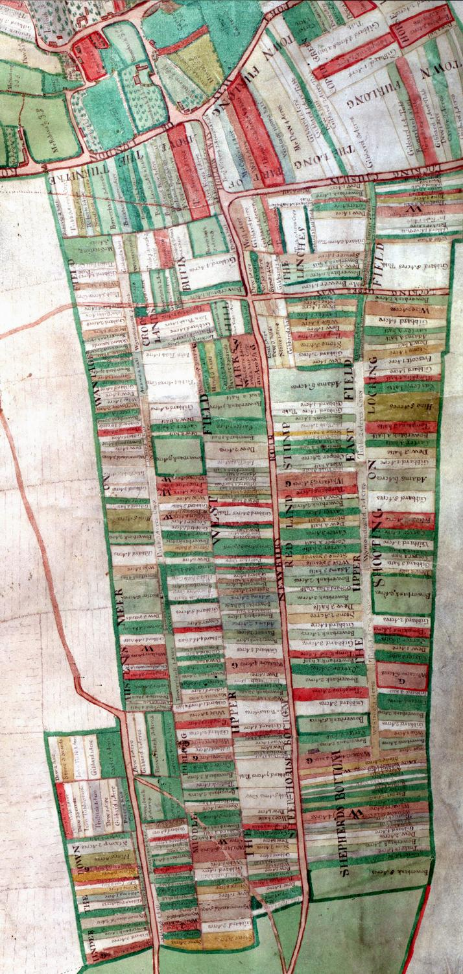
Although enclosure was late, the common field system at Charlton was typical. The extract taken from the 1754 map showing the two upper fields at Charlton shows many fundamental features of common arable fields (see Fig. 2.2). The large fields were divided into furlongs with eight in Upper West Field and five in Upper East Field. The layout of the arable field was very much determined by traditional husbandry techniques with the direction of the strips or lands in the furlong determined by the best and easiest direction for ploughing. Thus a slight rise or fall in the field might result in a change in the direction of the strips in the furlong. In Charlton, Larks Hill and The Land above the Turnpike were at right angles to most of the other furlongs in the two fields. Within each furlong were the intermixed strips of those with arable land in the township. For the most part the strips in a furlong were parallel to each other, but Town Furlong shows a pragmatic approach to the strips. Headlands were the strips running at right angles to the other lands in the furlong where the plough was turned. These are best illustrated in Upper East Field between Red Lands Stump and the furlong Shooting on Lockinge Field. Once all the strips were ploughed, the headland could be worked. At Harwell, Robert Loder planted some of his headlands to arable but others, called haddes, were planted to grass. The uniformity of layout of the field was further disrupted by the occasional shortened strips, often at right angles to the rest of the lands in the furlong, known as butts and triangular areas worked by hand in the corners known as gores. The position and shape of Under the Town Furlong suggests that it may have been land taken from the waste between Charlton and Wantage and incorporated into the arable. Originally the arable of each system would have been surrounded by the lord’s waste. Incorporating land in this manner was a typical and pragmatic medieval solution to a shortage of arable due to population pressure. By the mid-eighteenth century there had been considerable consolidation of the lands in Charlton. Messrs Tubbs (white), Gibbard (cream), Bowerbank (light green with dark surround), Tomkins (red), and Adams (light green) were actively amalgamating their holdings into larger blocks of land. Along the major furlong boundaries in the field were grassed areas known as meers and balks which marked the boundaries between lands. These gave access to the individual strips and provided grazing for tethered livestock. In addition to the grassed headlands, meers and balks, the fields were also crossed by a number of roads and footpaths. Some of these followed the boundaries of the fields, furlongs, and strips, but others cut across the strips.
Fig. 2.2 Upper East Field and Upper West Field, two of the four fields in the township of Charlton contain quintessential features of a common field system. Each field is divided into a number of furlongs and these into parallel strips or lands. The direction of the strips was determined by the lie of the land and the best direction for ploughing. The property of each owner is intermixed with others in the field but by 1754 several owners were consolidation their strips.
Source: BRO D/ECo P1

Each field was planted in a separate course of the arable rotation. Traditionally in a two-field system this was a corn crop followed by a fallow. Three-field arable land could be sown in various ways. In the southern common fields this was typically a winter corn crop of wheat or rye followed by a spring sown crop of barley or oats followed by a cropped or bare fallow. In the Midlands there was often a grain crop of barley, wheat, or rye followed by beans, peas, vetches, or oats and then a fallow. However, while the course in the rotation was based on the field, the different furlongs in that field could be planted with one of various crops. On the two-field system at Harwell Loder divided his lands between barley and wheat with some land planted to pulses and vetches. These last two crops were possibly a ‘hitched’ or catch crop planted between harvest and the sowing of the barley in the spring. It was often the case that the soil or condition of a particular furlong was best suited to one of the alternative crops - i.e. rye instead of wheat or vetches rather than oats or barley. However, evidence from Loder’s accounts suggests he had considerable freedom in the choice of his crop. What really mattered was that all the crops in the field were harvested before or at about the same time as the main crop. The fallow was sometimes left unplanted but part might be hitched with vetches, beans, peas, turnips, or grasses and clover. Once fed or harvested, the field was thrown open, or ‘breached’, and made common for the feeding of livestock. The normal rules of ownership associated with the strips in the field came to an end and everyone in the village who had grazing rights on the arable, the ‘right of shack’, used the whole field for livestock feeding. Because the fallow was open for common grazing for the whole year, hitching took a greater level of co-operation and agreement so that the crop was protected from grazing animals. This co-operation paid dividends. Hitching produced a larger, higher quality supply of feed. Well-fed animals produced more and better quality manure that resulted in a higher fertility level in the fields.

Because winter-feed was essential for the livestock, each holding also had an allocation of meadowland. Like the arable, the meadow was several and therefore closed to livestock in the spring until after the hay was mown and carried. After the harvest it was again thrown open to be grazed by those with the right of shack. Some of the meadowland was watered. This technique, practiced by Loder at Harwell by 1611, produced an earlier crop of grass and helped to increase its output. The right to use the meadow also varied. Some had full rights on the meadow. They would mow their hay then, once the harvest was complete and the land breached, put livestock onto the aftermath. These animals would graze until spring when the meadow was again closed to communal grazing and made several. Others only had partial rights to the meadows. Those from East and West Hendred and East and West Lockinge who had the right to the first cut of the hay crop in Ardington Meadow did not, for example, have the right to use the meadow for livestock once the hay was carried off the land. That was reserved for the commoners from Ardington alone. Others may have had the right to graze the meadow when common without having an allocation of land in the meadow. The way a meadow was divided also varied. Some people owned fixed strips in the meadow just like on the arable. However, in some meadows the ownership of the strips was not set. Each year lots were drawn to determine who would have each parcel. This random allocation gave everyone involved an equal chance of the best and worst grass. Such meadows were known as ‘lott meadows’. White Mead in East Challow had both fixed and lot strips. According to the glebe terrier of 1634 for Letcombe Bassett, the glebe included ‘five lottes one yeare and three another year and these lottes are to be parted yearely as they fall, between the parson of the said Letcombe Bassett and the Miller of the same parish equally.’ The glebe at Letcombe Regis had ‘two acres and a halfe, viz: in the furlong shoutinge upon Woodhill one acre and in the furlonge shouteinge upon the brooke one acre and a halfe more.’ Although the glebes were in different manors and parishes, they both made use of the same meadowland. Intercommoning, where people from a number of parishes shared meadowland and common, was practised on both Ardington Meadow – between East Lockinge, Ardington, and West and East Hendred, and White Mead – between the Challows, and Letcombe Regis and Letcombe Bassett.

Another key feature of the common-field village was its common or waste. Originally this was the unused land that surrounded the meadow and arable fields. By the end of the sixteenth century it was not empty or vacant, merely land used less intensively. It was used by the village to graze animals; it also supplied many other essentials of village life including wood for fuel, tools, and building; it was a source of stones and quarries; it supplied fruit, nuts, and the like to supplement the food from farming. This use of the waste came to be institutionalised in a number of rights of common providing people in the village with specific rights to exploit the lord’s waste. Throughout, however, the lord of the manor was the owner of the soil. The exact nature of an individual’s rights depended on the status of his or her holding on the lands of the manor. Often the number of animals a person could put on the waste was restricted to the number he could maintain through the winter. On some commons the number of animals each person could graze was controlled by stint or gait –i.e. the number of animals allowed according to the size of holding on the arable. On other commons grazing was unrestricted. There were a number of other rights of common that villagers, including those with no arable land, enjoyed. The right of pannage and of mast, i.e. the right to feeds such as acorns, nuts, and the like – made it possible for people to keep swine; the right of estover allowed wood to be collected for fuel, to maintain hedges, for house building and repairs, and to make tools; turbury gave the right to cut peat or turf for fuel. If there were sufficient land that those with right of pasture were not disadvantaged, the right to put sheep, beasts, and other animals on the waste could be extended to those with no land in the manor. This was known as common in gross.

The Decline of the Common Fields

In 1801 just over half of the agricultural land in the four parishes around Wantage remained in traditional common-field husbandry. Ten years later the area had fallen to under thirteen per cent. A way of life that was generations old was rapidly coming to an end. After 1868, when Charlton was finally enclosed, there was no common land left in these parishes. Common field husbandry was viewed by many of those with the power to bring about change as an archaic form of farming that had little to do with a modern progressive industrialised country. However, the negative attitude towards the common fields was not caused by a stagnating system incapable of change. There was considerable flexibility of cropping on the common fields. In the seventeenth century Robert Loder in Harwell was able to grow numerous crops on his land in the common field. At Letcombe Regis and East Challow two centuries later the instructions for husbandry during enclosure show that the flexibility had been maintained. They stipulated:
Every years land shall be sown for the season 1802 with such kind of Corn Grain of Grass Seed as the respective Owners or Occupiers shall think proper excepting that no Land which in this Season under a Crop of Wheat Barley or Oats shall be Sown or Planted with any White Straw Crop next season but shall be Planted or Drilled with Beans or Pease or Tares (the said Beans or Pease to be properly hoed twice at least) or with some other Vegetable Crop and no more than One fourth part of the said every years Land in each persons Occupation shall be Sown with Wheat for the Season of 1802…
We do hereby order and direct that the Agreement called the hitching Agreement shall be considered as the general rule or Guide till further directions are given.
This rotation was as advanced as many of those practised on enclosed arable fields of the time. Again, some thirty years later, at the time of the tithe survey before commutation, the tithe commissioners found that the common fields at East Lockinge continued to be worked in a four-course rotation of wheat, barley or oats, clover, and beans, peas, turnips, or fallow. Again this was a flexible and reasonably sophisticated rotation.

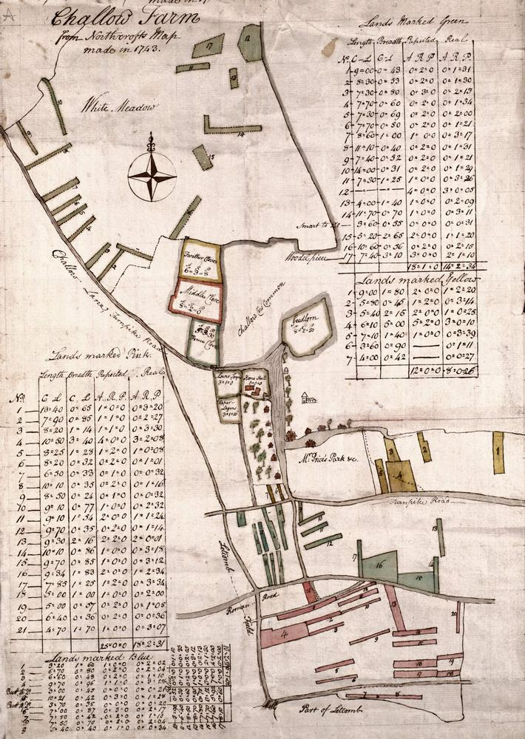
The problem with the common and/or open field husbandry was not so much one of flexibility, but more one of complexity, inconvenience, and inefficiency. It only allowed a limited amount of specialisation and individual initiative. The complexity and inconvenience of the common fields can be more easily understood by looking at a map of the lands belonging to Challow Farm in the three common fields and the meadow of East Challow (see fig. 2.3). Common field maps such as this were important documents for estate owners in that they helped to keep track of land in the fields and meadow. Because the location of the strips was so complex and because the land was generally farmed by tenants rather than the owner himself, it was not uncommon for the exact location of estate land to be unknown. The 1743 map shows the scattered strips of a relatively large holding in East Challow. Like in the hamlet of Charlton, the homestead was typically located on the road as it passed through the village. Around the house were the traditional enclosed croft or backfield and two other small closes. The other farmsteads of the village were also found along the main roads of the village. There were also another four small closes – i.e. areas of enclosed land across the turnpike from the homestead. Challow Farm had over 43 acres of arable land scattered in 45 strips throughout the three common fields, Eblands, Challow, and Great Challow. It also contained almost fifteen acres of meadow in another seventeen strips in White Mead (see table 2.2). Here commoners from the townships of East Challow, West Challow, Letcombe Regis, and Letcombe Bassett had intercommoning rights to this meadowland. The land in the meadow was allocated both by lott and through permanent possession. The occupier of Challow Farm had the same land each year. In addition to the
Fig. 2.3 The location and distribution of strips in the common arable and meadow was inconvenient and inefficient. Challow Farm, East Challow, was one of the larger farms in the hamlet. Interestingly, even the location of the individual strips within the fields was often a mystery to the owner. Maps made locating the estate land simpler.
Source: BRO D/EW P21
97.35 acres of land in the various closes, the arable fields and the meadows, Challow Farm would have had rights to graze the waste and common. At the time of the enclosure award for Letcombe Regis and East Challow in 1804, the farm belonged to Exuperious Turnor. He claimed common of pasture for ‘3 cows in Great Challow Common at all commonable times, common of pasture in White Mead for such stock of horses cows sheep as are kept in East Challow at all commonable times, and the exclusive right to the feed of the
Table 2.1 Distribution and size of unenclosed holdings of Challow Farm, East Challow
Field | Land use | Number of strips in field | Area of holding in field (acres) | Size of lands (acres)
 |  |  |  | Avg. | Max. | Min.
Eblands (yellow) | Arable | 7 | 8.16 | 1.66 | 3.06 | 0.17
Challow (blue-green) | Arable | 17 | 16.51 | 0.97 | 4.50 | 0.13
Great Challow (pink) | Arable | 21 | 18.69 | 0.89 | 3.55 | 0.20
Total arable |  | 45 | 43.36 | 0.96
White Meadow | Meadow | 17 | 14.71 | 0.85 | 3.03 | 0.19
Total |  | 62 | 58.07 | 0.94
Source: BRO D/EW P21
roads in East Challow’. The holding was widely dispersed around the village. Time spent travelling from one strip to the next for husbandry operations, moving equipment around the holding, and supervising labour was saved once land in a parish was consolidated and enclosed.
The biggest problem with communal husbandry was simple. It was becoming increasingly inappropriate for the economic and social conditions of the late eighteenth and nineteenth centuries. It developed in an earlier period to meet the needs of a largely self-sufficient village. At Wigston Magna, Leicestershire in the sixteenth century W.G. Hoskins found:
the parish grew enough flax and hemp to meet its own needs for linen sheets, napkins, towels, and clothing; it produced enough wool from its own sheep to keep the five or six village tailors well supplied. Its barley, grown over several hundred acres every year, supplied food and drink; and its wheat, rye, oats, peas, and beans provided food for all men and beasts. Every cottage and farmhouse had its own poultry (chiefly geese, but ducks and hens were numerous), and most kept pigs and bees. All had herb gardens and many had small orchards; so the village had meat, bacon, eggs, cheese, butter, milk, honey, apples, and herbs of all kinds.
This type of non-specialised, non-intensive husbandry was well suited to a self-sufficient open and common field village. As the market economy developed and agricultural specialisation according to regional and local strengths became more common, areas, particularly on the heavier soils in the north of the four parishes were found to be best suited to livestock feeding, meat and wool production, and dairying. On the other hand, parts of the downs in the south could profitably be converted from waste to arable production. The increasing stress on specialised production eventually exposed a fundamental weakness of the system and led to its demise. The common field system was simply too universal. There was little scope for the system to be adapted to meet varying soil conditions, topography, and marketing opportunities. Generally, communal agriculture discouraged individual initiative. Traditional attitudes and methods dominated the system. The shift towards specialised, more productive and intensive, scientific agriculture was beyond the scope of a system established to provide the needs of a largely self-sufficient community. Enclosure facilitated such change.

Beckett, 1989, 26-35; Shaw-Taylor, 2002, 63-9
BRO D/EF M5
A late tenth century charter identifies open fields at Coerlatum (Charlton). Tate, 1943, 60
BRO D/ELs A8 (also transcribed with an excellent introduction by G.E. Fussell, 1936)
Gibbons and Davy, 88
For a general account of the use of high value plants in agriculture see Thirsk, 1997
Tate, 1943, 61
BRO D/EW/E9
13 Geo. III c. 81
Tate, 1967, 35-8
BRO D/ELs A8
BRO D/ELs A8, f 50
BRO D/ELs A8 ; Fussell, xiii
Hoskins, 1950, 74
BRO D/ELs A8
BRO D/P 143 A
BRO D/ELs A8
BRO D/EL/01/1
For a detailed explanation of the division of meadowland by lot see Tate, 1967, 32-4
BRO D/EF P3 Mortimer, 79, 98-9, 103; 3
Mortimer, 98
Mortimer, 99
Young, 1808, 56
Gonner, 5-14
This is particularly clear in the works of the late eighteenth century agriculturalists Arthur Young and William Marshall.
BRO D/ELs A8
BRO D/EM O8
National Archives, Kew IR18 /13196
This information was supplied by Dr John Chapman
Mortimer, 79, 98-9, 103; BRO D/EF P3
Award and BRO D/EEl E9– shows that he claimed the dwelling and closes and is likely to have held the remainder of the land in the arable fields and meadow.
Hoskins, 1957b, 191

